DESCRIPTION

Background

Mike Goodman, the head of Product Management of a retail products company, is responsible for determining which products his company should continue to offer for sale and which products should be discontinued from the company’s product catalog.

Objective

To build a dashboard that will present monthly sales performance by product segment and product category to help client identifying the segments and categories that have met or exceeded their sales targets, as well as those that have not met their sales targets.

Domain: Ecommerce

Dataset Description

We will be using two datasets here i.e. [Sample - Superstore and Sales_Target](https://github.com/Simplilearn-Edu/Tableau-10).

* **Sample -Superstore which covers Orders data from 2014 - 2017**;

Within this file you will find the following fields:

|  |  |
| --- | --- |
| **Field** | **Description** |
| Row ID | Observation Index |
| Order ID | Unique Order ID of a product |
| Order Date | Order Placement Date |
| Ship Date | Shipment Date of the placed order |
| Ship mode | Shipment mode of the placed order |
| Customer ID | Unique Customer ID |
| Customer Name | Name of the Customer |
| Segment | Product Segment (i.e.HomeOffice/Corporate/Consumer etc.) |
| Country | Unique Country Name |
| City | Unique City Name |
| State | Unique State Name |
| Postal Code | Area wise Postal code |
| Region | Especially the part of a country |
| Product ID | Unique Id respective to Product |
| Category | Product category |
| Sub-Category | Product Subcategory |
| Product Name | Unique Product Name |
| Sales | Sales Amount |
| Quantity | The amount or number of a material |
| Discount | A deduction from the usual cost of something |
| Profit | Obtain a financial advantage or benefit |

**Sales-Target will cover the target data;**

Within this file you will find the following fields:

|  |  |
| --- | --- |
| **Field** | **Description** |
| Category | Product category |
| No. of Records | Unique Record |
| Order Date | Order Placement Date |
| Sales Target | Targeted Sales to be achieved |
| Segment | Product Segment (i.e.HomeOffice/Corporate/Consumer etc.) |

Analysis Tasks

1. Use the Saved Sample – Superstore dataset.
2. Create a bullet chart with Category and Segment dimensions and Sales measures.
3. Blend the data with the Saved Sample - Sales Target data set to bring in the Sales Target measure.
4. Color code the chart to identify Categories and Segments that are above or below target.
5. Add the year of sales to the view to identify trends and outliers.
6. Add a filter so that the user can select one, more than one, or all years.
7. Create a dashboard with this view.

Sample Output

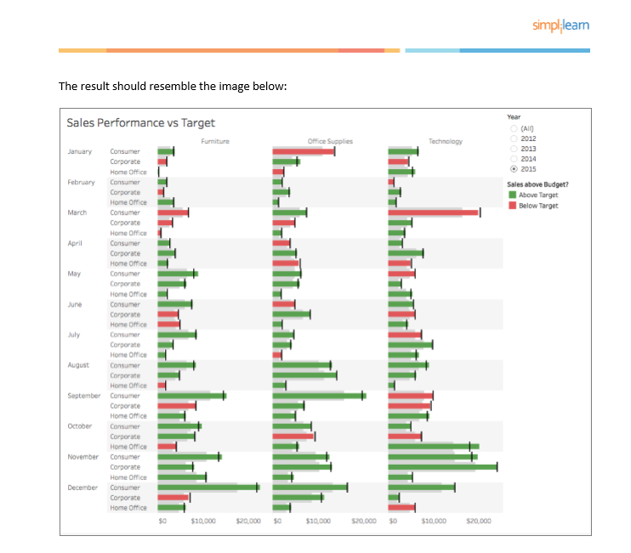

Download the Datasets from [here](https://github.com/Simplilearn-Edu/Tableau-Datasets/tree/master/Project%202)